**EXPERIMENT 1**

**hafiz ahmad and 19L-1316**

# INTRODUCTION TO HTML

**Objective:** Introduction to HTML language.

* HTML is the standard markup language for creating Web pages.
* HTML stands for **H**yper **T**ext **M**arkup **L**anguage
* HTML is not a programming language, it is a **markup language.** A markup language is a set of **markup tags whose** purpose is to **describe page content**

**HTML Elements:**

An HTML element is defined by a start tag, some content, and an end tag:

<tagname> Content goes here... </tagname>

* The HTML **element** is everything from the start tag to the end tag
* HTML tags are keywords (tag names) surrounded by **angle brackets** like <html>
* HTML tags normally **come in pairs** like <b> and </b>
* The first tag in a pair is the **start tag,** the second tag is the **end tag**
* The end tag is written like the start tag, with a **forward slash** before the tag name
* Start and end tags are also called **opening tags** and **closing tags**
* Some HTML elements have **empty content**
* Empty elements are **closed in the start tag**
* Most HTML elements can have **attributes**

**Web Browsers:**

The purpose of a web browser (Chrome, Edge, Firefox etc.) is to read HTML documents and display them as web pages. The browser does not display the HTML tags, but uses but uses them to determine how to display the document.

**Exercise 1:** A basic HTML page structure is as given 1 below. Please replace the name and rollnumber with your own. Save this file as Ex1_<your rollnumber>.html and then open it in a browser. Put a screenshot of the output in the 2nd column

|  |  |
| --- | --- |
| <!DOCTYPE html> <html> <head> <title>Your Name</title></head> <body> <h1>Your Name</h1> <p>Your rollnumber</p> </body> </html> |  |

### **Example Explained**

* The <!DOCTYPE html> declaration defines that this document is an HTML5 document
* The <html> element is the root element of an HTML page
* The <head> element contains meta information about the HTML page
* The <title> element specifies a title for the HTML page (which is shown in the browser's title bar or in the page's tab)
* The <body> element defines the document's body, and is a container for all the visible contents, such as headings, paragraphs, images, hyperlinks, tables, lists, etc.
* The <h1> element defines a large heading
* The <p> element defines a paragraph

For a complete list of HTML tags please see <https://www.w3schools.com/tags/default.asp>

A few are discussed below:

**HTML Lists**

An unordered list starts with the <ul> tag. Each list item starts with the <li> tag. The list items are marked with bullets (typically small black circles).

<ul>  
<li>EE</li>  
<li>CS</li>  
<li>BBA</li>  
</ul>

**Exercise 2:** Please edit the exercise1 you just did and add a list of courses you are taking this semester to the HTML page. Paste your HTML code as well as a screenshot of the output you get on running it in the browser in the space below

|  |  |
| --- | --- |
| <!—Your code -->  <!DOCTYPE html>  <html>  <head>  <title>Hafiz Ahmad</title></head>  <body>  <h1>Hafiz Ahmad</h1>  <p>19L-1316</p>  <ul>      <h4>LIST OF COURSES in Fall 2023</h4>      <li>Fundamentals of Data Bases</li>      <li>Electromagnetic Theory</li>      <li>Final Year Project-2</li>      </ul>  </body>  </html> | <!-- Output --> |

**HTML Styles**

Please explore <https://www.w3schools.com/html/html_styles.asp> to see how you can style/format various HTML elements and try to style those you have already used.

**HTML Images**

<img src="temp.jpg" width="250" height="142" />

To display an image on a page, you need to use the src attribute. Src stands for "source". The value of the src attribute is the URL of the image you want to display. The height and width attributes are used to specify the height and width of an image.

**Exercise 3:** Please edit the exercise2 you just did and add the front.jpg image lying in the lab folder. Paste your HTML code as well as a screenshot of the output you get on running it in the browser in the space below

|  |  |
| --- | --- |
| <!—Your code -->  <!DOCTYPE html>  <html>  <head>  <title>Hafiz Ahmad</title></head>  <body>  <h1>Hafiz Ahmad</h1>  <p>19L-1316</p>  <ul>      <h4>LIST OF COURSES in Fall 2023</h4>      <li>Fundamentals of Data Bases</li>      <li>Electromagnetic Theory</li>      <li>Final Year Project-2</li>      </ul>      <img src="temp.jpg" width="250" height="142" />  </body>  </html> | <!-- Output --> |

**HTML Links**

A hyperlink (or link) is a word, group of words, or image that you can click on to jump to a new document or a new section within the current document. When you move the cursor over a link in a Web page, the arrow will turn into a little hand.  
Links are specified in HTML using the <a> tag.  
The <a> tag can be used in two ways:

1. To create a link to another document, by using the href attribute
2. To create a bookmark inside a document, by using the name attribute

<a href="http://www.google.com">This is a link</a>

<a href="http://www.google.com/" target="_blank">Google Search</a>

The target attribute specifies where to open the linked document.  
The name attribute specifies the name of an anchor.  
The name attribute is used to create a bookmark inside an HTML document.

**Linking Within a Single Page**

Maybe you would like to give someone a way back to the top of the page when they are at the bottom. Or maybe you want to divide it into sections and use a table of contents at the top. Well, the way to do this is to use a named anchor, which is a specific area of your page you want to make a link to. You could link to any part of the page, but for now, let's say you want to create a link to the top of your page. To do this, go to the top of the body section (right after the body tag). Now type the following tag:   
<a name="top"></a>

You can place any name you wish inside the quotes. This just makes it easy to see where we are going to end up. Now, go anywhere between the body tags and type this link:

<a href="#top">Back to the Top</a>

If you click on this link, you will be sent back to the top of the page.

**Using Images as HTML Links**

To use an image as a link, you will have to use two things you have already learned.   
1. How to [create a link](http://www.webconcerns.co.uk/tutorial/stage_02_intermediate/linking_part_01.asp).   
2. How to [add an image to the page](http://www.webconcerns.co.uk/tutorial/stage_02_intermediate/images_part_01.asp).

<a href="http://www.google.com">  
<img src="sunset.jpg">  
</a>

**Exercise 4:** Please edit the exercise3 you just did and link the front.jpg image to the website of FAST (www.nu.edu.pk) such that upon clicking it the FAST website will open in a new browser tab. Paste your HTML code below

**CODE:**

<!DOCTYPE html>

<html>

  <head>

    <title>Hafiz Ahmad</title>

  </head>

  <body>

    <h1>Hafiz Ahmad</h1>

    <p>19L-1316</p>

    <ul>

      <h4>LIST OF COURSES in Fall 2023</h4>

      <li>Fundamentals of Data Bases</li>

      <li>Electromagnetic Theory</li>

      <li>Final Year Project-2</li>

    </ul>

    <a href="https://lhr.nu.edu.pk/" target="_blank">

      <img src="temp.jpg" width="250" height="142" />

    </a>

  </body>

</html>

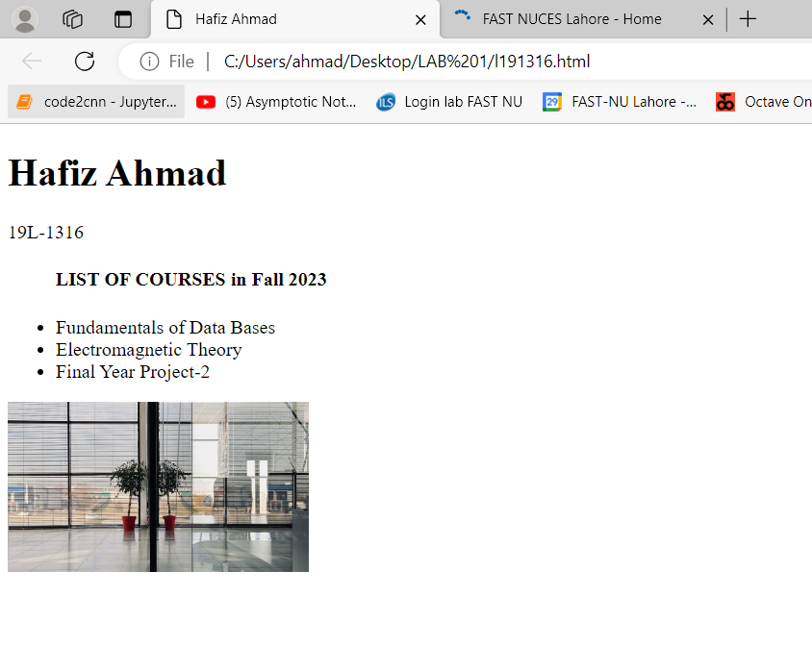

**HTML Tables**

Tables are defined with the <table> tag.

A table is divided into rows (with the <tr> tag), and each row is divided into data cells (with the <td> tag). td stands for "table data," and holds the content of a data cell. A <td> tag can contain text, links, images, lists, forms, other tables, etc.

If you do not specify a border attribute, the table will be displayed without borders. Sometimes this can be useful, but most of the time, we want the borders to show.

Header information in a table are defined with the <th> tag.

<table border="1">  
<tr>  
<th>Department</th>  
<th>Course</th>  
</tr>  
<tr>  
<td>CS</td>  
<td>Data Structure</td>  
</tr>  
<tr>

<td>EE</td>  
<td>Circuit Analysis</td>  
</tr>  
</table>

**INPUT Control**

1. Input(Text)

<input id="Text1" type="text" value="Please Enter City" />

1. Input(Password)

<input id="Password1" type="password" value="dummy" />

1. Input(Checkbox)

<input id="Checkbox1" type="checkbox" checked="true" />

1. Input(Radio)  
   <input id="Radio1" type="radio" checked="true" />
2. Input(Button)

<input id="Button1" type="button" value="button" />

**Exercise 5:** Please use the table tag and the input tags in the html page you have been working on so far. Paste a screenshot of the output you get in the space below

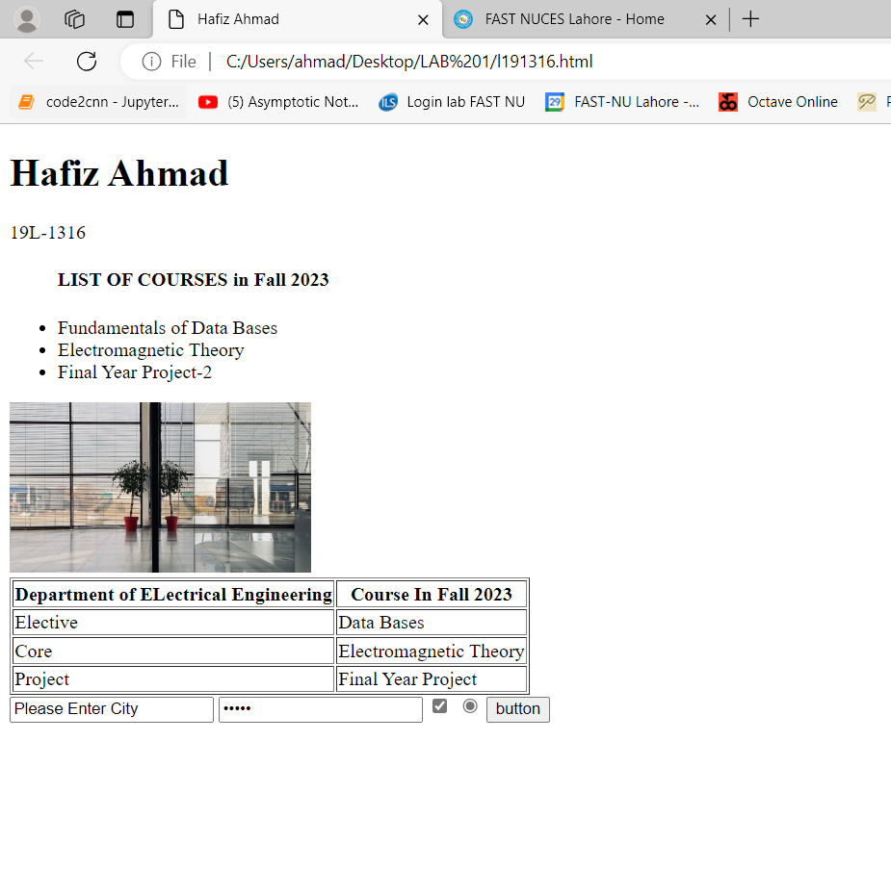

## 

## Exercise 6: Add the table as shown in the Figure below to your HTML page. Please save your HTML file as well this document you have been building during this lab session on xeon.



 